BOOMERSHOOT 2025 Long Range Precision Rifle Event with High Explosives as Targets
May 2nd-4th
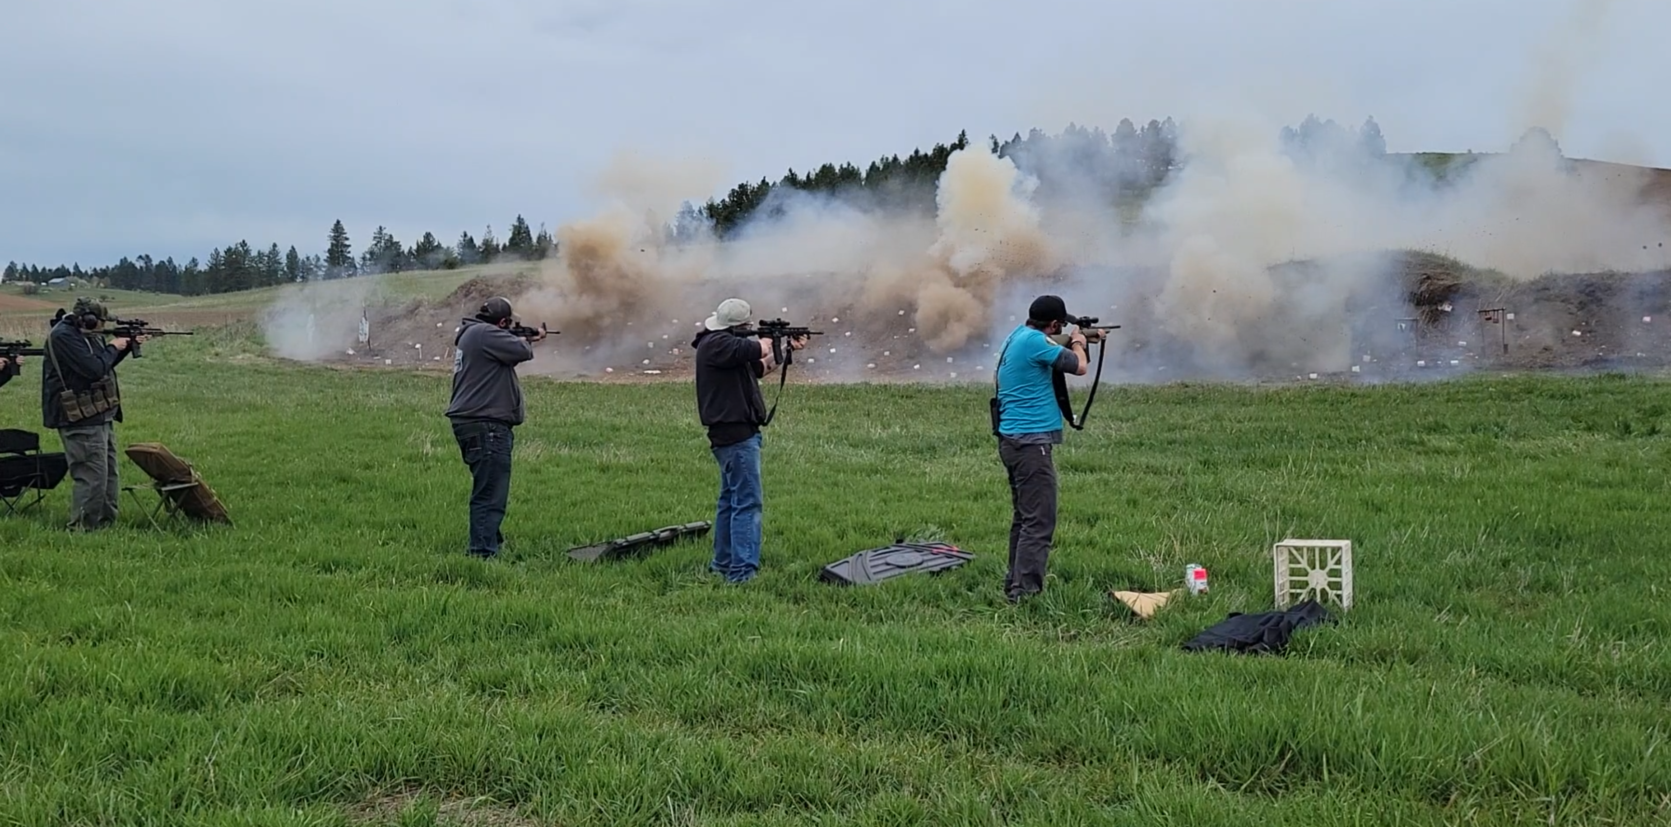
High Intensity Event
Event Schedule
- Friday and Saturday, May 2nd and 3rd: Precision Rifle Clinic with Bill Waites and staff:
- Friday and Saturday May 2nd and 3rd, 5 PM: High Intensity (reactive targets at 25 yards)
- Saturday, May 3rd at 6 PM: Boomershoot dinner
- Sunday, May 4th: Boomershoot Precision Rifle Event with reactive targets at 375 yards to 700 yards

Spectators Welcome
REGISTRATION opens for everyone December 30, 2024! https://entry.boomershoot.com/
- Register soon to get your preferred shooting position!
- Location: near Cavendish, Idaho; 1003 Meridian Road, Lenore, Idaho; GPS N 46.5433º W 116.39128º

Go to www.boomershoot.com for more information. Email: Joe@Boomershoot.com. Phone: 208-301-4254
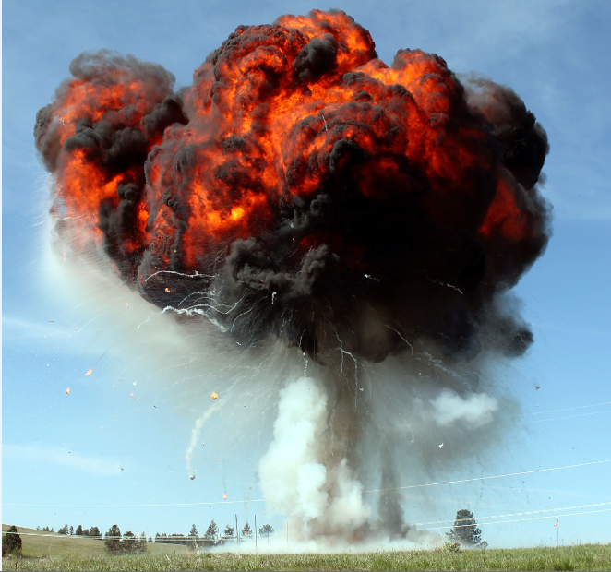 |  | 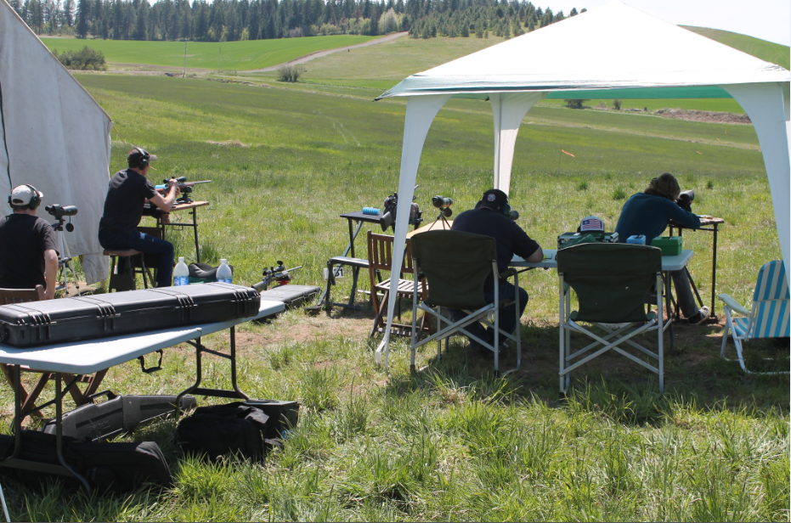 |  | 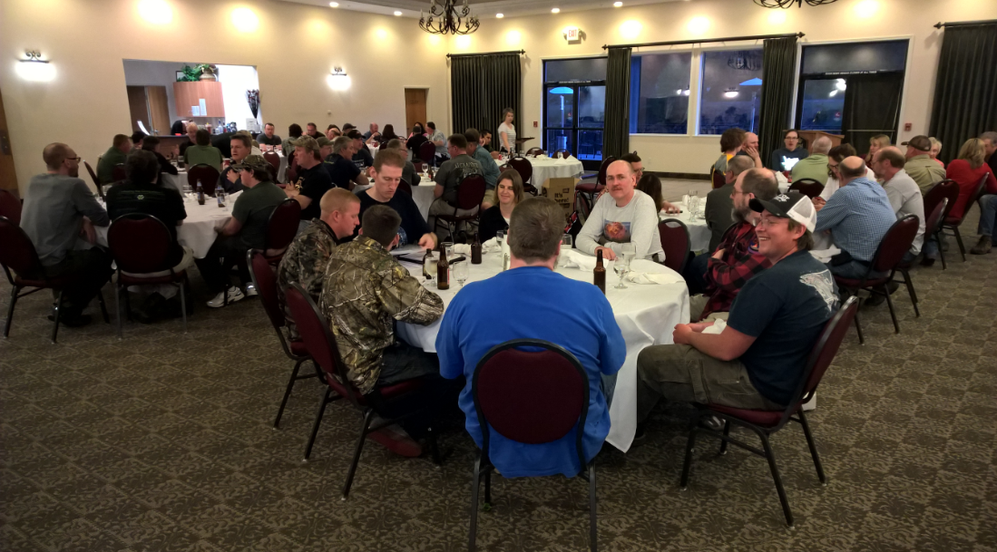
Opening Fireball |  | Precision shooters doing their thing |  | Dinner

